ENTREPRENEURSHIP DEVELOPMENT CELL 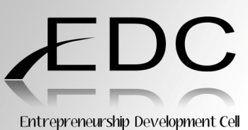

Name of the event: Selling of chocolate modaks (GANESH CHATHURTHI)
Date: 16th September 2015
Start Time: 10:00am
End Time: 1:00pm

AIM:
The most awaited Ganesh festival, Vinayaka Chavithi or Ganesh Chaturthi was getting close, EDC decided that it will make and sell chocolate modaks in the college premises. It was a task where team communication and coordination were important among members. The task of making the chocolate modaks was well planned and executed.

GROUNDWORK:
In order to make chocolate modaks following groundwork involved was:
- The idea was approved in the meeting.
- Then permission for using the college microwave and fridge were approved.
- Then permission for keeping the desk in the college foyer was approved.
- In order to make chocolate modaks arrangements were made.
- To build the marketing skills, every member were taught how to sell chocolate modaks to students in the college premises.

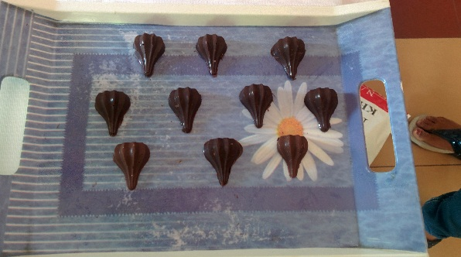
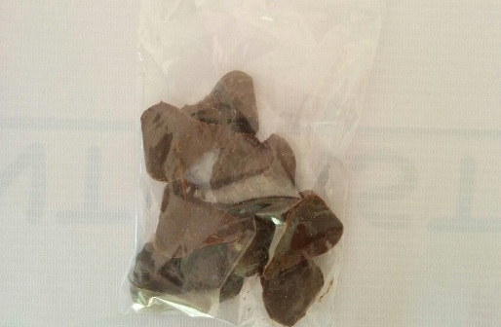
SUMMARY:
DAY 1:
- EDC had put up desk at 10:00am.
- EDC directors appointed few core students for making the chocolate modaks and others member’s job was to sell and do the PR for modaks.
- The cost of small chocolate modaks were Rs 20/- and normal chocolate modaks were 30/-
- Each modak were packed and sealed in the small plastic bags.
- Various shapes of modaks were designed.
- Professor Anita Agarwal was invited to see our chocolate modaks.
- EDC made a good profit from the chocolate modaks.
- The stall got closed at 1:00pm.

The event went very well and was brilliantly executed by the organising team and all the members of Entrepreneurship development cell.

